Types of Quantifiers
# Source: AI Source: Provided by: [Data Path: Persons Table -> ID Column: 1, Name_En Column: Motasem Essam] -> From: [ChatGPT] on [7/28/2025]
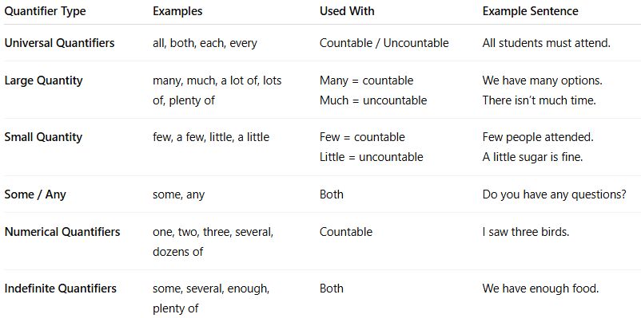

Quantifier Type | Examples | Used With | Example Sentence
Universal Quantifiers | all, both, each, every | Countable / Uncountable | All students must attend.
Large Quantity | many, much, a lot of, lots of, plenty of | Many = countableMuch = uncountable | We have many options.There isn’t much time.
Small Quantity | few, a few, little, a little | Few = countableLittle = uncountable | Few people attended.A little sugar is fine.
Some / Any | some, any | Both | Do you have any questions?
Numerical Quantifiers | one, two, three, several, dozens of | Countable | I saw three birds.
Indefinite Quantifiers | some, several, enough, plenty of | Both | We have enough food.

